Parallel and Distributed Computing

CSE4001

Fall Semester 2020-21

Lab Assignment 3

**ISHAAN OHRI**

**18BCE0265**

**Aim:**

Write a simple OpenMP program to demonstrate the use of reduction and critical clause

* Sum of ‘n’ array Using Reduction Clause
* Product of ‘n’ array using Reduction Clause
* Show a suitable example for Critical Clause

sum using reduction clause

**Source Code:**

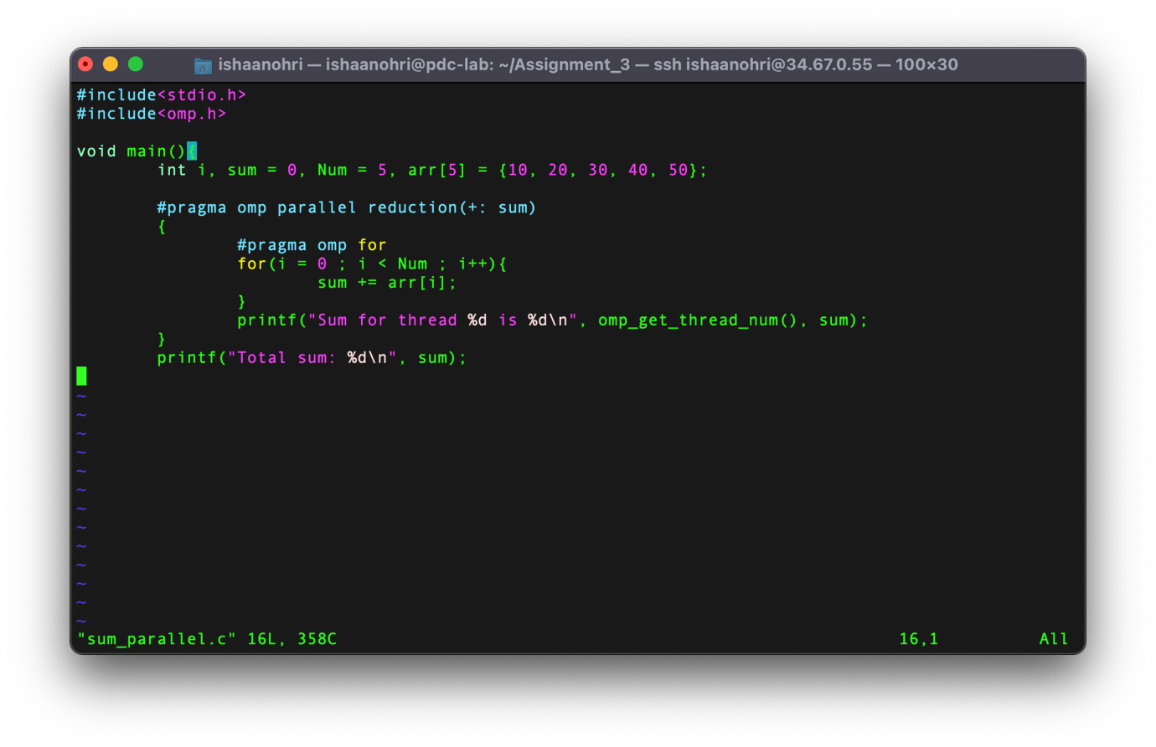

**Execution:**

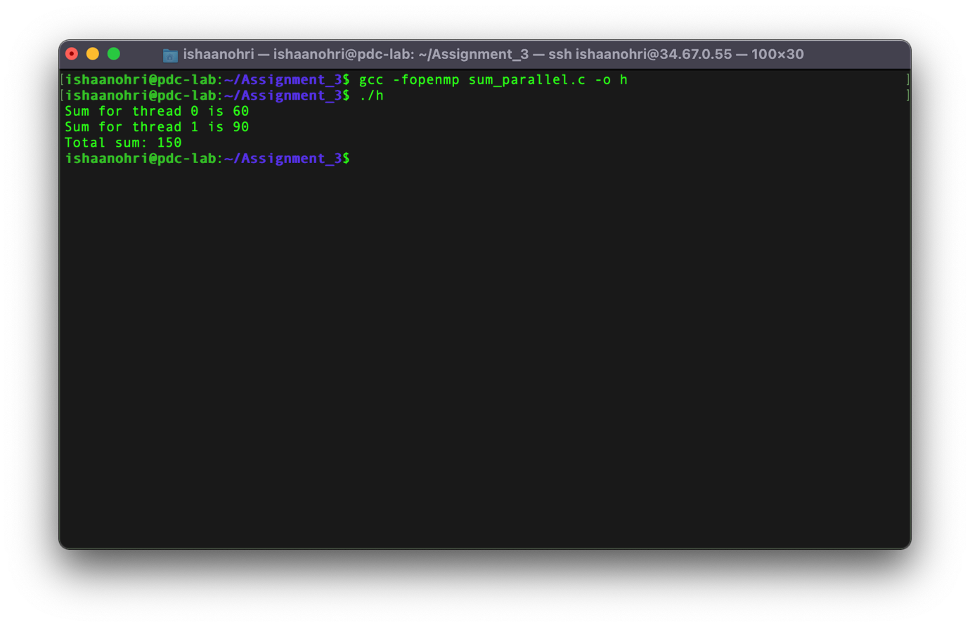

product using reduction clause

**Source Code:**

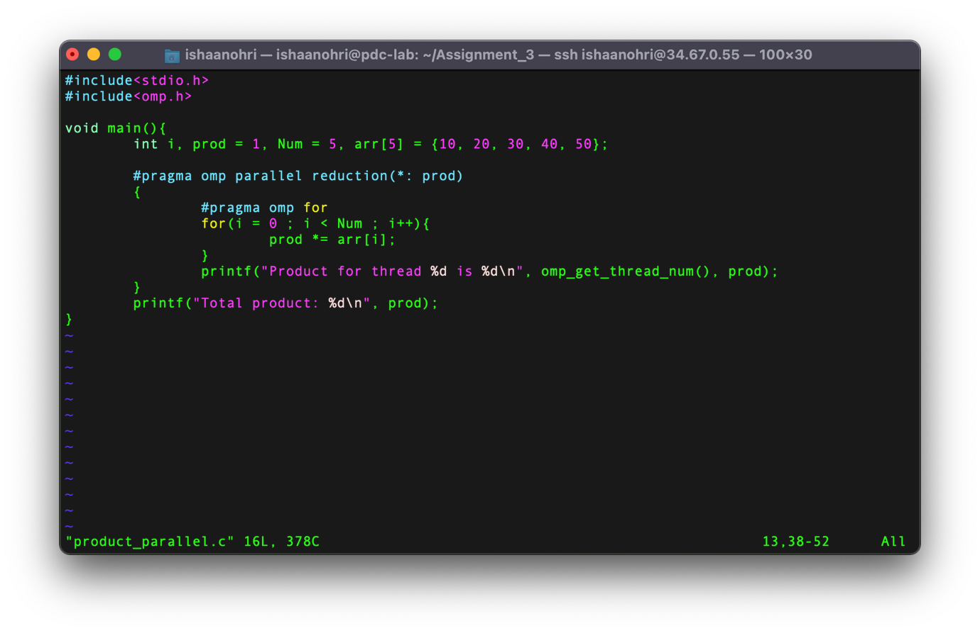

**Execution:**

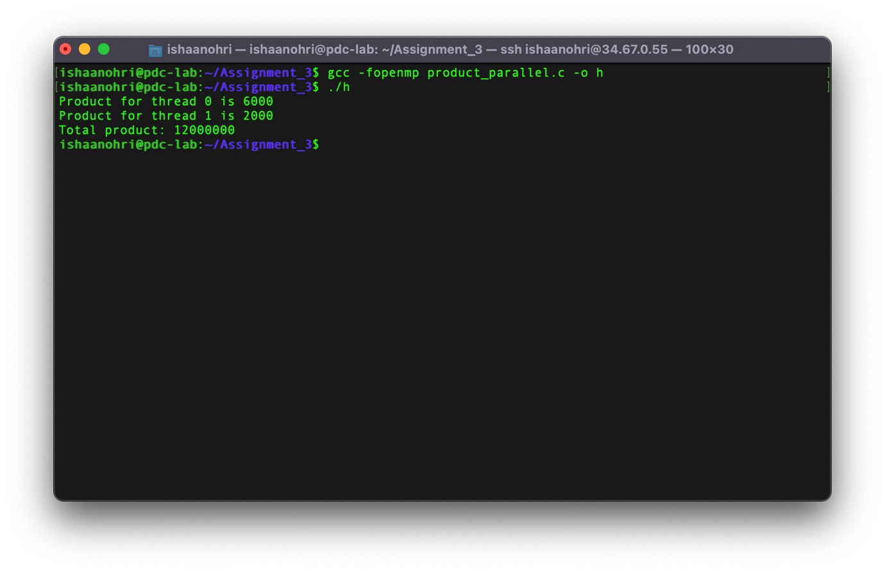

example of critical clause

**Source Code:**

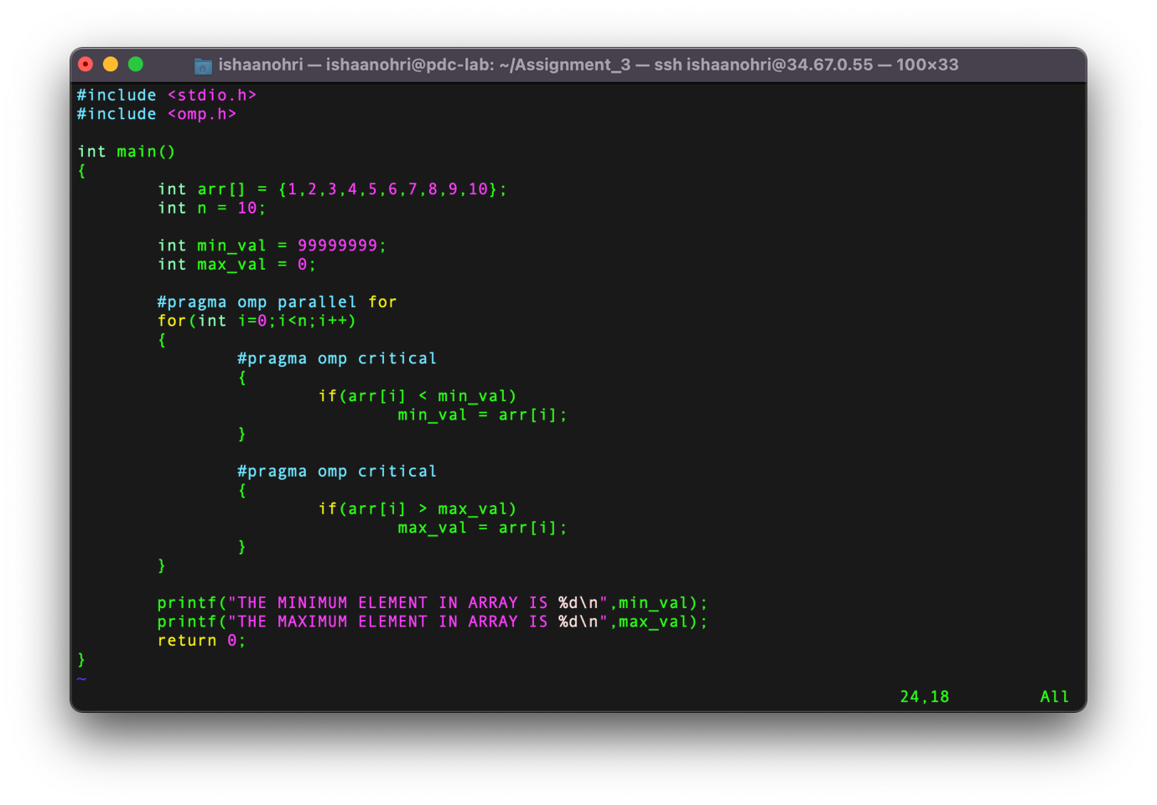

**Execution:**

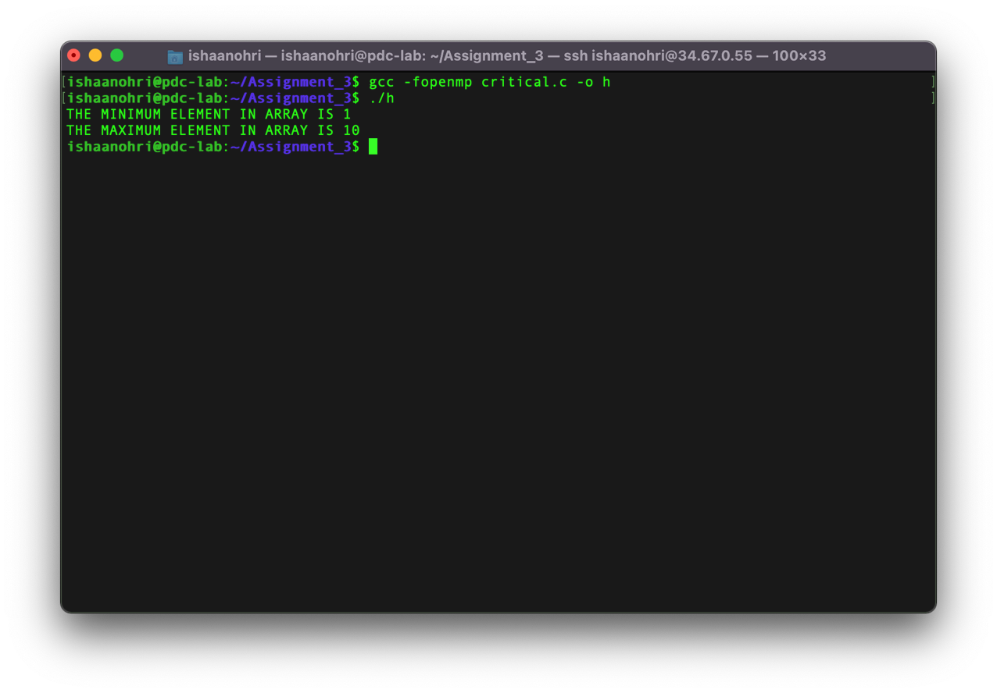

**Result:**

From this experiment I understood the usage of *reduction* *clause* using parallel pragma and arrays by sum of array elements, and product of array elements. Along with the use of *reduction clause*, I even understood the usage of *critical clause* by finding the minimum and the maximum element in the array. The above experiment was conducted and all results along with the source code have been attached above in the document. The experiment was assisted by Dr Deepak. I thank sir for his assistance.